**Day 2 lab assignments**

1. Use **CSS3 columns** on any set of paraagraph.
2. Make simple photo gallery, and use transition to make the photos zoom outs with animation on hover (**Use transform: scale() with transition**). 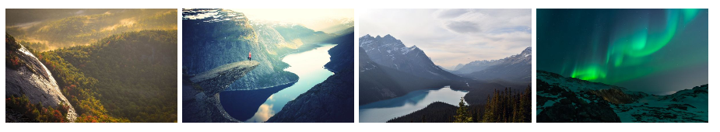
3. Use **transition** to make animated search input that its width will increase gradually on focus, and returns to its normal width gradually on blur.
4. Make the following buttons when you hover over any one of them the background become the same color of border. Use CSS transition.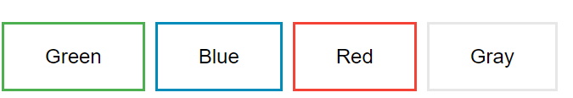
5. Make a div and write your name on it and make it appears vertical on the page and fill the page height (use transformation). Like the following image.
6. Design the following CV

